SafeSport

SafeSport is associated with USA Swimming to help protect all swimmers. The course takes approximately 30-45 minutes to complete. This course is required to be on the deck at swim practices and it also helps our team be recognized by USA Swimming as a safe and certified swim team, allowing us to host meets. Our coaches will have a list of people who have been certified and parents/friends/family that do not have their SafeSport Class certification, will not be able to be on deck.
SafeSport Parent’s Guide to Misconduct in Sport is the required course and can be accessed through the USA Swimming website on the parent account. This course is best taken upon a computer. Upon completion of the course, please take a screenshot or create some sort of proof showing you’ve successfully finished it. (USA Swimming does not always link well to show this as completed.) Please keep a copy of this completion on your phone and a provide a printed copy to the coach. This is the best way to ensure we can recognize you have done your part to keep our swimmers safe.
Instructions from USA Swimming Account:
- Login to your PARENT account. You will only have this account if you are currently registered under USA Swimming:
- Find the “Education” tab, select “Course Catalog”

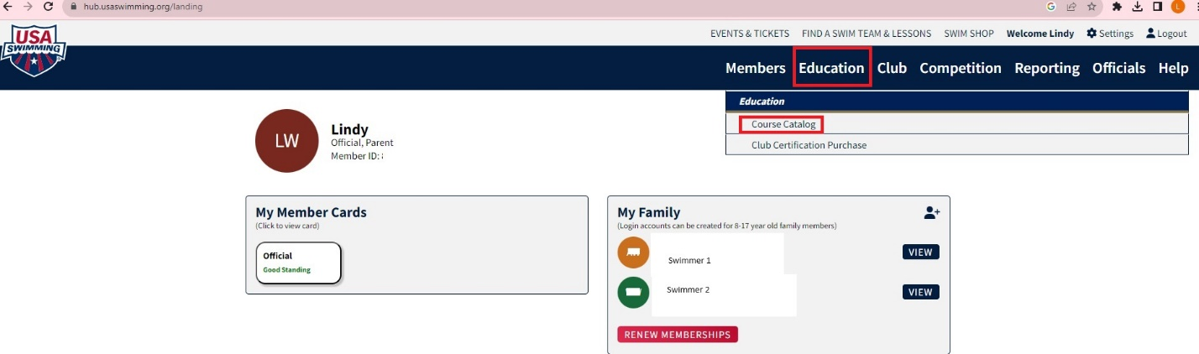

- There are many courses offered. Scroll until you find “Parents Guide to Misconduct in Sports.”

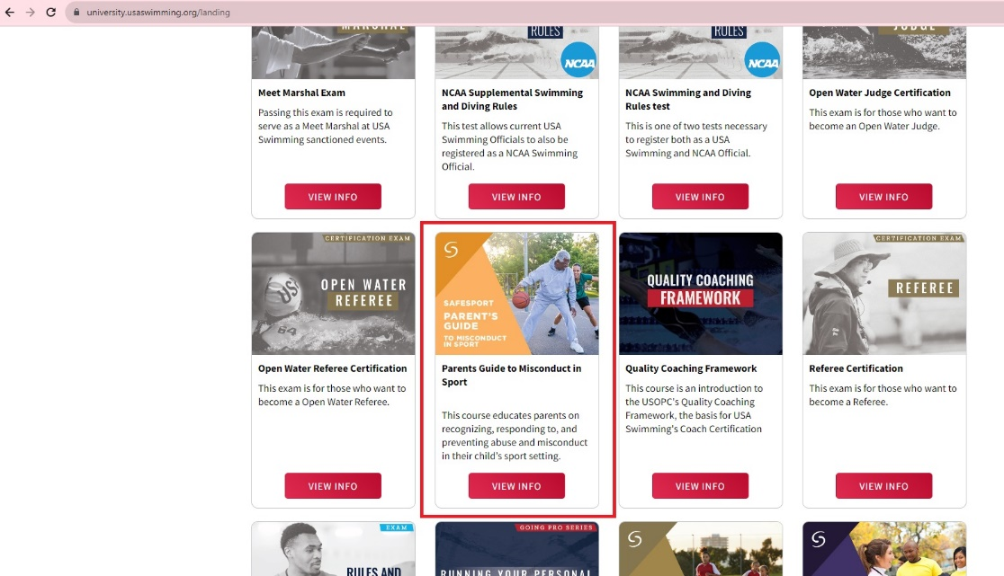

- The page should look similar to below. You will use the “START” button to begin the course. You can take breaks during the course – which will be explained as you begin the process.
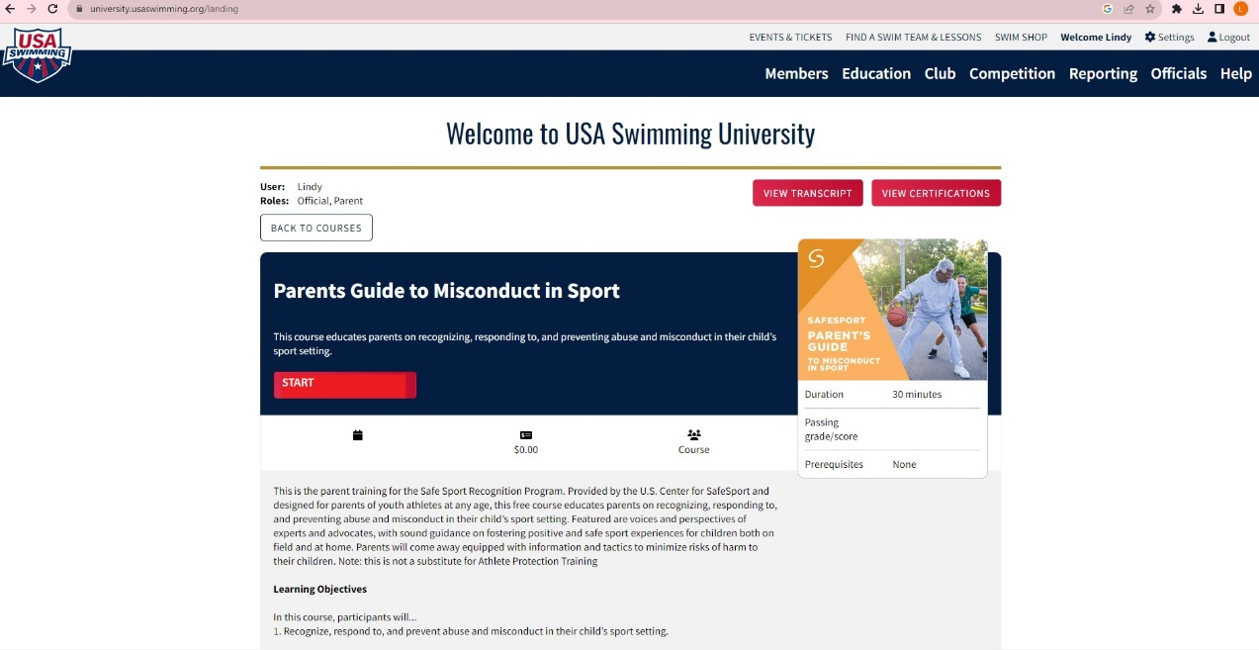
- When the course is complete, the box on the right (below the basketball player) will show your passing score, and under the small calendar icon it will show the date the course was successfully completed.
- If you do not see the course is showing as complete, please log completely out of USA Swimming and try logging in a day or so later. If it does not show as complete, go back to this page and open the course again – on that page it will show that you’ve completed it or the link to SafeSport will. Please print this if you are struggling to prove completion. You should not need to create a SafeSport account to login for a certification!
If you do go through SafeSport for this process instead of through USA Swimming, here are the steps from the SafeSport homepage:
- Under “TRAINING AND EDUCATION”, drop down to “SAFESPORT COURSES FOR ALL”
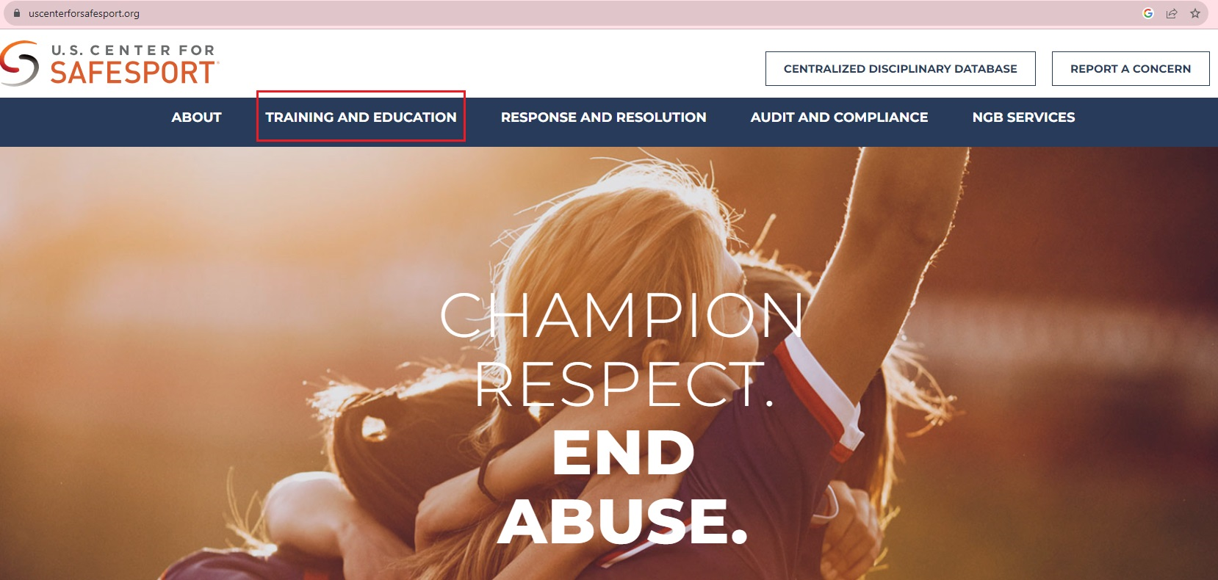
- Bottom of the page, select “GET TRAINED NOW”

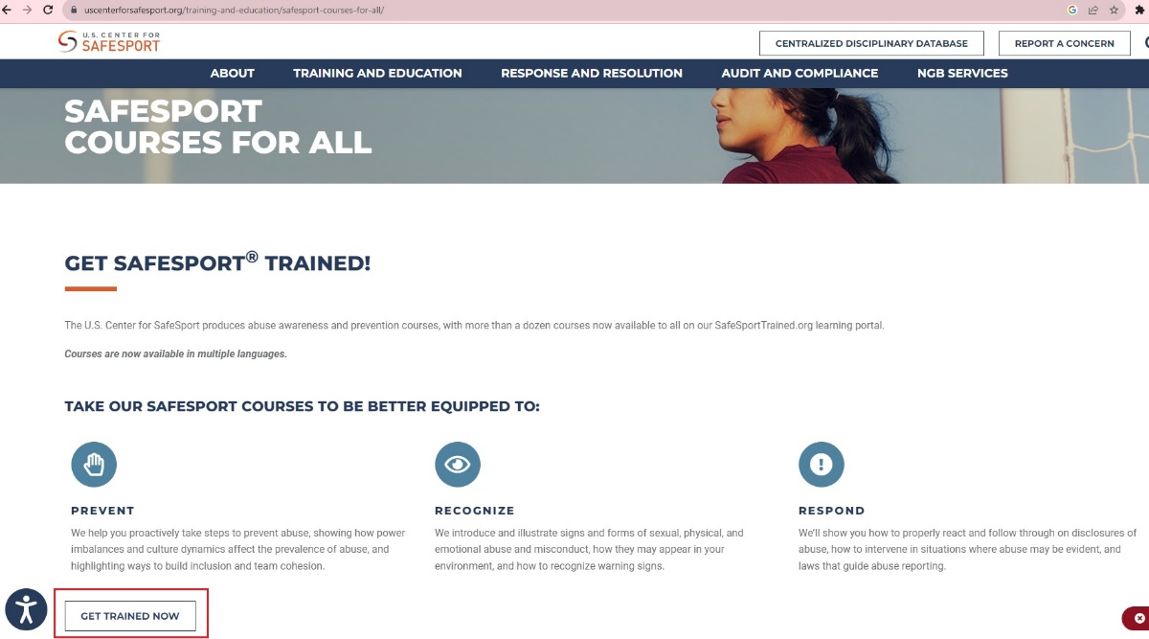

- You will need to create an account and login:

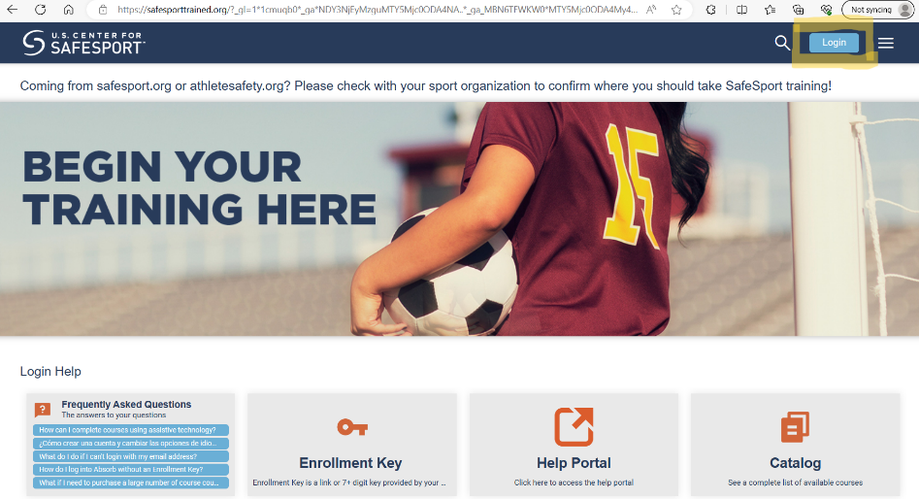

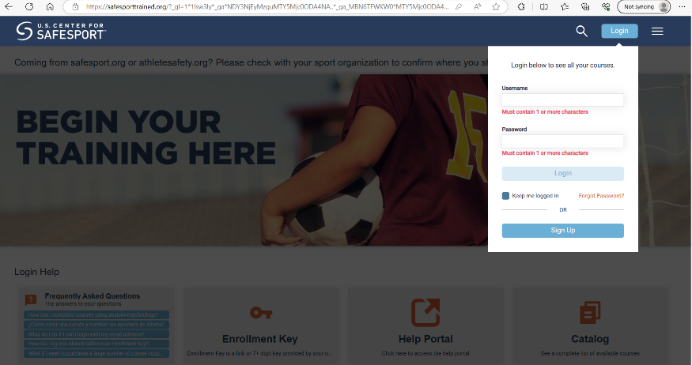

- Select “My Courses”
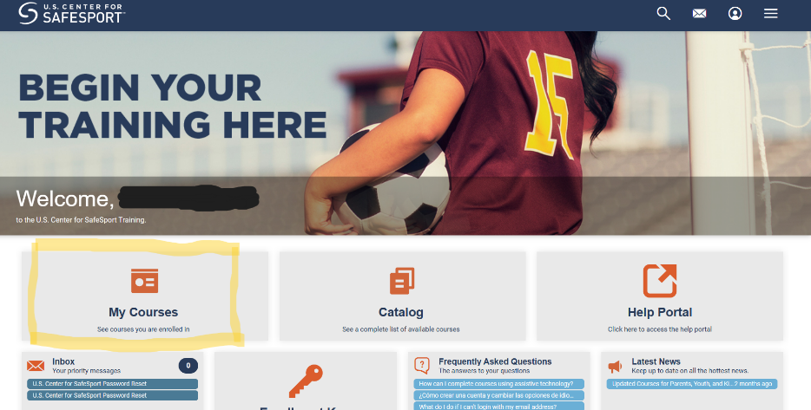

- Choose “Parents Guide to Misconduct in Sports – USA Swimming”
